**SQL Project (Marketing Analysis)**

# **Tables**

Here are the tables you will be using

* Sustainable_clothing
* Transactions
* Marketing_campaigns

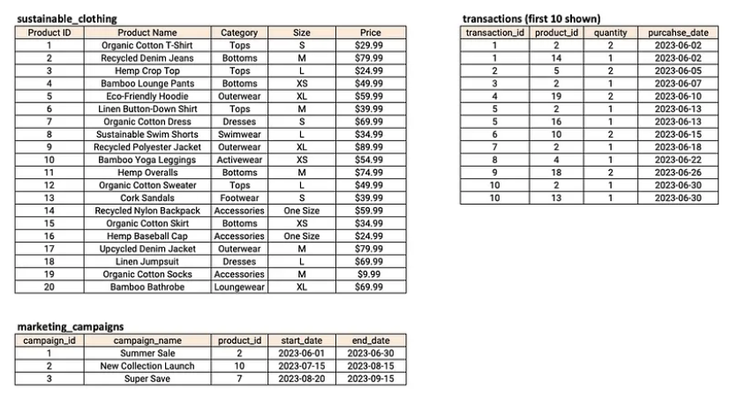

## Creating Tables

### Creating Sustainable_clothing Table

CREATE TABLE sustainable_clothing (  
product_id INT PRIMARY KEY,  
product_name VARCHAR(100),  
category VARCHAR(50),  
size VARCHAR(10),  
price FLOAT  
);

**Inserting values in Sustainable_clothing Table**

-- Insert data into the table  
INSERT INTO sustainable_clothing (product_id, product_name, category, size, price)  
VALUES  
(1, 'Organic Cotton T-Shirt', 'Tops', 'S', 29.99),  
(2, 'Recycled Denim Jeans', 'Bottoms', 'M', 79.99),  
(3, 'Hemp Crop Top', 'Tops', 'L', 24.99),  
(4, 'Bamboo Lounge Pants', 'Bottoms', 'XS', 49.99),  
(5, 'Eco-Friendly Hoodie', 'Outerwear', 'XL', 59.99),  
(6, 'Linen Button-Down Shirt', 'Tops', 'M', 39.99),  
(7, 'Organic Cotton Dress', 'Dresses', 'S', 69.99),  
(8, 'Sustainable Swim Shorts', 'Swimwear', 'L', 34.99),  
(9, 'Recycled Polyester Jacket', 'Outerwear', 'XL', 89.99),  
(10, 'Bamboo Yoga Leggings', 'Activewear', 'XS', 54.99),  
(11, 'Hemp Overalls', 'Bottoms', 'M', 74.99),  
(12, 'Organic Cotton Sweater', 'Tops', 'L', 49.99),  
(13, 'Cork Sandals', 'Footwear', 'S', 39.99),  
(14, 'Recycled Nylon Backpack', 'Accessories', 'One Size', 59.99),  
(15, 'Organic Cotton Skirt', 'Bottoms', 'XS', 34.99),  
(16, 'Hemp Baseball Cap', 'Accessories', 'One Size', 24.99),  
(17, 'Upcycled Denim Jacket', 'Outerwear', 'M', 79.99),  
(18, 'Linen Jumpsuit', 'Dresses', 'L', 69.99),  
(19, 'Organic Cotton Socks', 'Accessories', 'M', 9.99),  
(20, 'Bamboo Bathrobe', 'Loungewear', 'XL', 69.99);

**Creating marketing_campaigns table**

CREATE TABLE marketing_campaigns (  
campaign_id INT PRIMARY KEY,  
campaign_name VARCHAR(100),  
product_id INT,  
start_date DATE,  
end_date DATE,  
FOREIGN KEY (product_id) REFERENCES sustainable_clothing (product_id)  
);

**Inserting values in marketing_campaigns table**

-- Insert data into the table  
INSERT INTO marketing_campaigns (campaign_id, campaign_name, product_id, start_date, end_date)  
VALUES  
(1, 'Summer Sale', 2, '2023-06-01', '2023-06-30'),  
(2, 'New Collection Launch', 10, '2023-07-15', '2023-08-15'),  
(3, 'Super Save', 7, '2023-08-20', '2023-09-15');

**Creating Transactions Table**

-- Create the table  
CREATE TABLE transactions (  
transaction_id INT PRIMARY KEY,  
product_id INT,  
quantity INT,  
purchase_date DATE,  
FOREIGN KEY (product_id) REFERENCES sustainable_clothing (product_id)  
);

**Inserting values in Transactions Table**

-- Insert data into the table  
INSERT INTO transactions (transaction_id, product_id, quantity, purchase_date)  
VALUES  
(1, 2, 2, '2023-06-02'),  
(2, 14, 1, '2023-06-02'),  
(3, 5, 2, '2023-06-05'),  
(4, 2, 1, '2023-06-07'),  
(5, 19, 2, '2023-06-10'),  
(6, 2, 1, '2023-06-13'),  
(7, 16, 1, '2023-06-13'),  
(8, 10, 2, '2023-06-15'),  
(9, 2, 1, '2023-06-18'),  
(10, 4, 1, '2023-06-22'),  
(11, 18, 2, '2023-06-26'),  
(12, 2, 1, '2023-06-30'),  
(13, 13, 1, '2023-06-30'),  
(14, 4, 1, '2023-07-04'),  
(15, 6, 2, '2023-07-08'),  
(16, 15, 1, '2023-07-08'),  
(17, 9, 2, '2023-07-12'),  
(18, 20, 1, '2023-07-12'),  
(19, 11, 1, '2023-07-16'),  
(20, 10, 1, '2023-07-20'),  
(21, 12, 2, '2023-07-24'),  
(22, 5, 1, '2023-07-29'),  
(23, 10, 1, '2023-07-29'),  
(24, 10, 1, '2023-08-03'),  
(25, 19, 2, '2023-08-08'),  
(26, 3, 1, '2023-08-14'),  
(27, 10, 1, '2023-08-14'),  
(28, 16, 2, '2023-08-20'),  
(29, 18, 1, '2023-08-27'),  
(30, 12, 2, '2023-09-01'),  
(31, 13, 1, '2023-09-05'),  
(32, 7, 1, '2023-09-05'),  
(33, 6, 1, '2023-09-10'),  
(34, 15, 2, '2023-09-14'),  
(35, 9, 1, '2023-09-14'),  
(36, 11, 2, '2023-09-19'),  
(37, 17, 1, '2023-09-23'),  
(38, 2, 1, '2023-09-28'),  
(39, 14, 1, '2023-09-28'),  
(40, 5, 2, '2023-09-30'),  
(41, 16, 1, '2023-10-01'),  
(42, 12, 2, '2023-10-01'),  
(43, 1, 1, '2023-10-01'),  
(44, 7, 1, '2023-10-02'),  
(45, 18, 2, '2023-10-03'),  
(46, 12, 1, '2023-10-03'),  
(47, 13, 1, '2023-10-04'),  
(48, 4, 1, '2023-10-05'),  
(49, 12, 2, '2023-10-05'),  
(50, 7, 1, '2023-10-06'),  
(51, 4, 2, '2023-10-08'),  
(52, 8, 2, '2023-10-08'),  
(53, 16, 1, '2023-10-09'),  
(54, 19, 1, '2023-10-09'),  
(55, 1, 1, '2023-10-10'),  
(56, 18, 2, '2023-10-10'),  
(57, 2, 1, '2023-10-10'),  
(58, 15, 2, '2023-10-11'),  
(59, 17, 2, '2023-10-13'),  
(60, 13, 1, '2023-10-13'),  
(61, 10, 2, '2023-10-13'),  
(62, 9, 1, '2023-10-13'),  
(63, 19, 2, '2023-10-13'),  
(64, 20, 1, '2023-10-14');

# **Case Study questions**

**Q1. How many transactions were completed during each marketing campaign?**

**Q2. Which product had the highest sales quantity?**

**Q3. What is the total revenue generated from each marketing campaign?**

**Q4. What is the top-selling product category based on the total revenue generated?**

**Q5. Which products had a higher quantity sold compared to the average quantity sold?**

**Q6. What is the average revenue generated per day during the marketing campaigns?**

**Q7. What is the percentage contribution of each product to the total revenue?**

**Q8. Compare the average quantity sold during marketing campaigns to outside the marketing campaigns.**

**Q9. Compare the revenue generated by products inside the marketing.**

**Q10. Rank the products by their average daily quantity sold.**